**Sprint-2**

|  |  |
| --- | --- |
| **DATE** | **16november 2022** |

|  |  |
| --- | --- |
| **TEAM ID** | **PNT2022TMID45918** |
| **Project Name** | **IoT Based smart crop Protection system for agriculture** |
| **Maximum mark** | **20 marks** |

STEP1: Download and Install NODE JS.

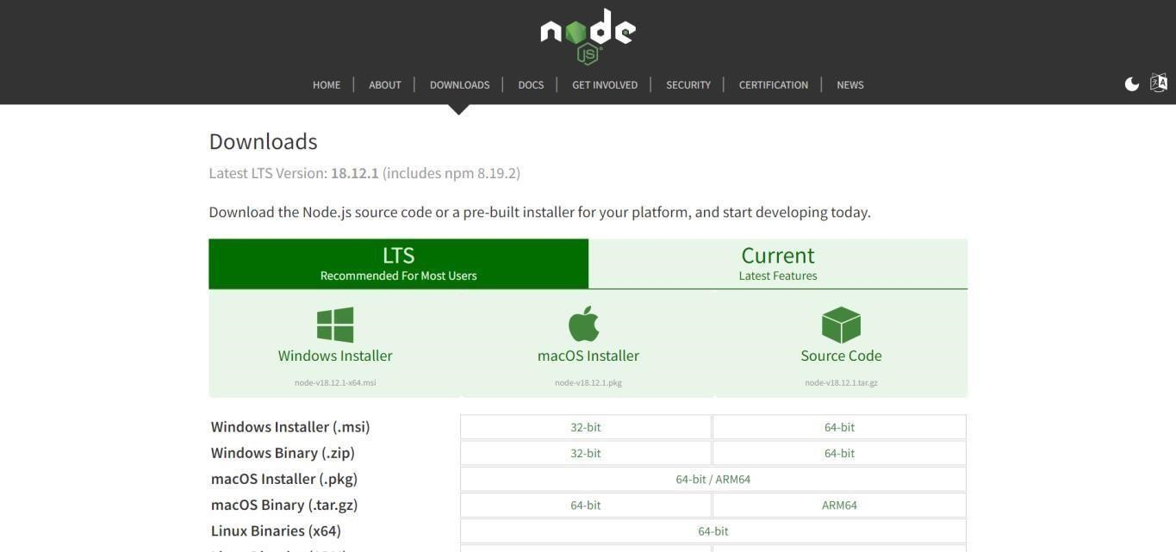

STEP2: Setup node.js and configure command prompt for error check.open node-red from the generated link.

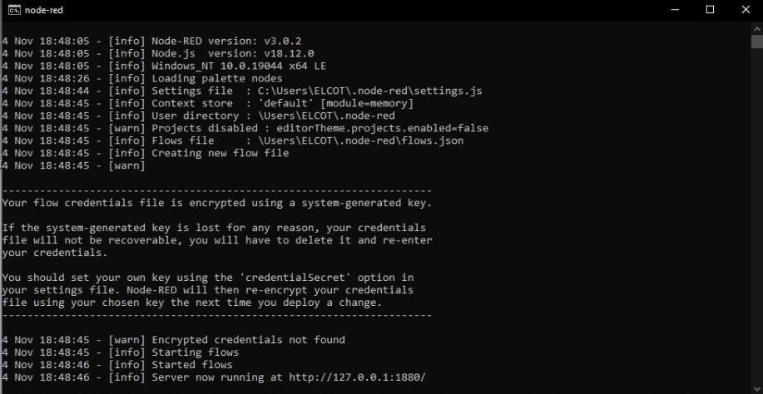

STEP3: Connect IBM IOT in and Debug 1 and Deploy.

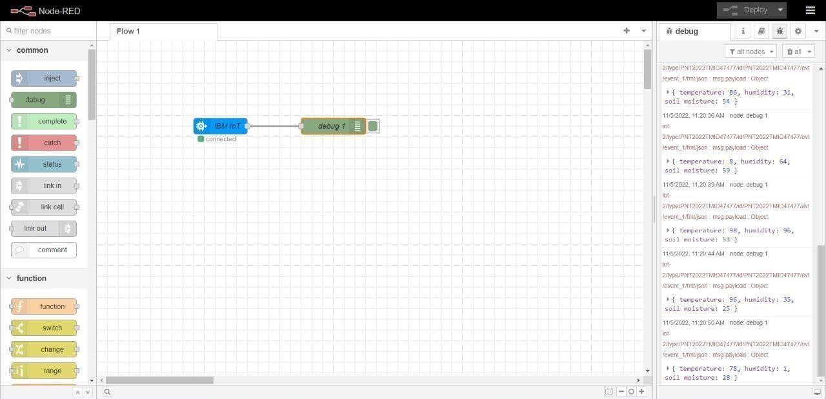

STEP4: Edit gauge node (Here the gauge nodes are named as Temperature, Humidity and Soil moisture).

